**BATCH FILE EXECUTION**

**Exp no:-2**

**Aim:**

To create a Windows batch file.

**Procedure:**

**Step 1 :** Open a text file, such as a Notepad or WordPad document.

**Step 2 :** Add your commands, starting with @echo [off], followed by, each in a new line, title [title of your batch script], echo [first line], and pause.

**Step 3 :** Save your file with the file extension BAT, for example, test.bat.

**Step 4 :** To run your batch file, double-click the BAT file you just created.

**Step 5 :** To edit your batch file, right-click the BAT file and select Edit.

And here's the corresponding command window for the example above:

# 1.Create a new text document

A batch file simplifies repeatable computer tasks using the Windows command prompt. Below is an example of a batch file responsible for displaying some text in your command prompt. Create a new BAT file by right-clicking an empty space within a directory and selecting New, then Text Document.

# 1.Code

Double-click this New Text Document to open your default text editor. Copy and paste the following code into your text entry.

>> @echo off

>> echo hello

>> Pause

>> echo This is new

>> echo this is second one

>> pause

# To save as bat file

The above script echoes back the text "Welcome to batch scripting!" Save your file by heading to File > Save As, Test.bat.

# 2.To run as bat file

Once you'd saved your file, all you need to do is double-click your BAT file.

**Output:**

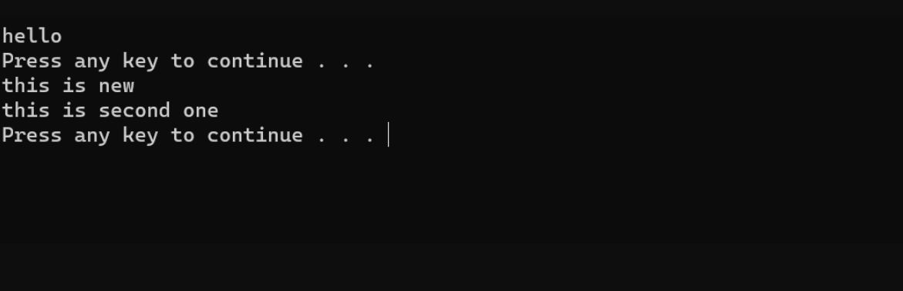

**Result:**

Hence the batch file executed successfully.